Graphical Output

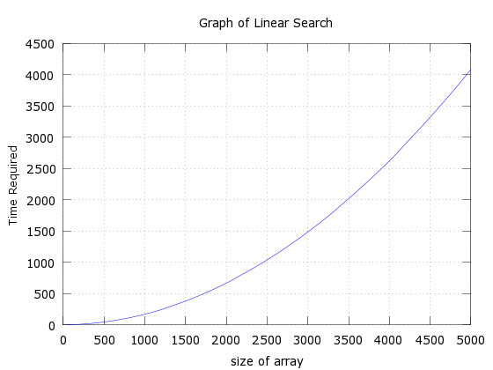

Figure 1 Graph of linear search

X coordinate represents size of array

Y coordinate represents time (100 unit represents 1 seconds)

The graph shows that with the increase in the size of array, time required to search the key also increases using linear search algorithm

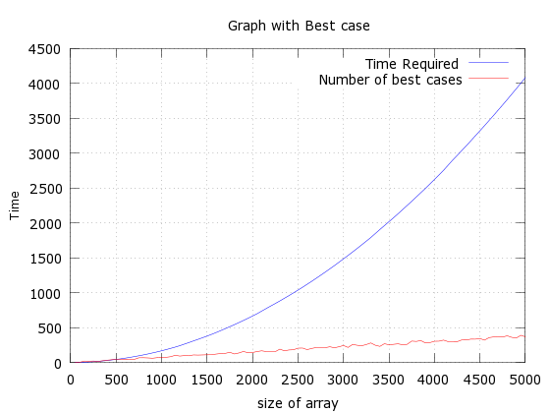

Figure 2 Graph_best

X coordinate represents size of array

Y coordinate represents time (100 unit represents 1 seconds)

Blue colored line represents time required to search the key in given array elements and red line represent best case search. Best case search is the search case where the key element is found by searching in first one-third array size.

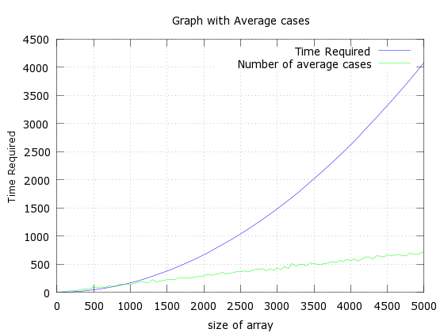

Figure 3 Graph of linear search

X coordinate represents size of array

Y coordinate represents time (100 unit represents 1 seconds)

Blue colored line represents time required to search the key in given array elements and green line represent average case search.

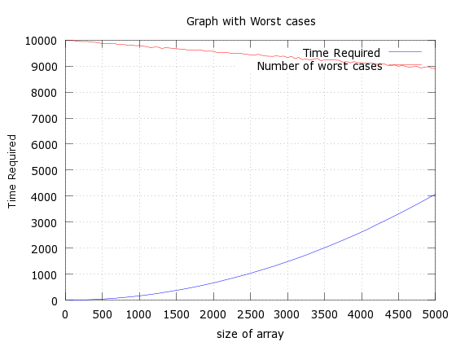

Figure 4 Graph of linear search

X coordinate represents size of array

Y coordinate represents time (100 unit represents 1 seconds)

Blue colored line represents time required to search the key in given array elements and red line represent worst case search. A search case is termed as worst case if the key is found in the last one-third of array size or if the key does not exist in that array.

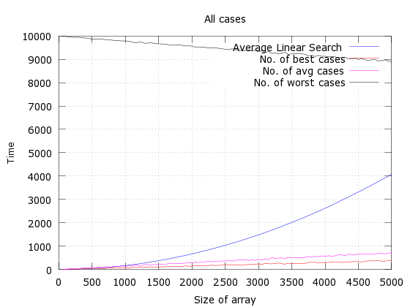

X coordinate represents size of array

Y coordinate represents time (100 unit represents 1 seconds)

Blue colored line represents time required to search the key in given array elements.

Red colored line represents best case search.

Magenta colored line represents average case search.

Black colored line represents worst case search.